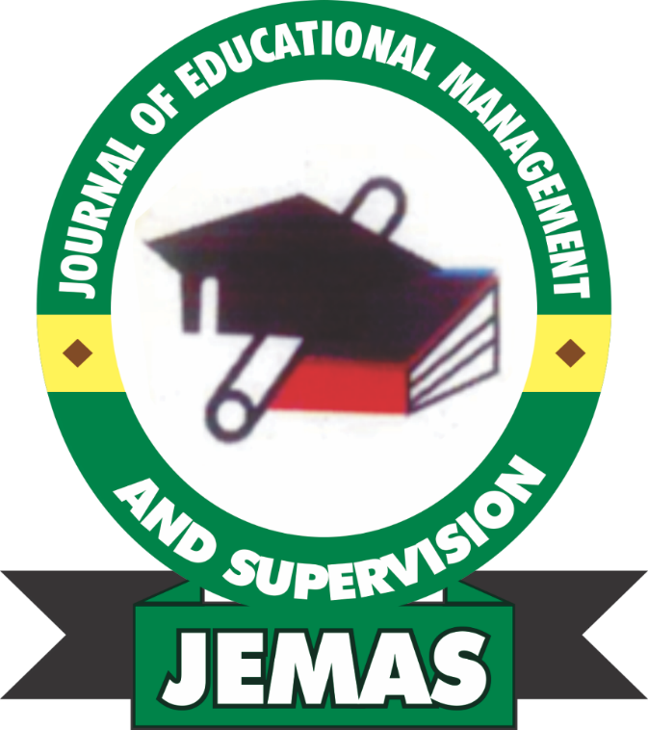

JOURNAL OF
EDUCATIONAL MANAGEMENT
AND SUPERVISION

Published in the Department of Educational Administration and Planning,
Joseph Sarwuan Tarka University Makurdi

Online Access: jemas.uam.edu.ng
Vol. 7, No. 1, 2026 ISSN: 2636-4514

JOURNAL OF EDUCATIONAL MANAGEMENT AND SUPERVISION (JEMAS)



Published in the Department of Educational Administration
and Planning,
Joseph Sarwuan Tarka University, Makurdi

Online Access: jemas.uam.edu.ng
Vol. 7, No. 1, 2026 ISSN: 2636-4514

JOURNAL OF EDUCATIONAL MANAGEMENT AND SUPERVISION (JEMAS)

EDITORIAL BOARD MEMBERS

Editor-in-Chief
Prof. (Mrs.) R.C. Odeh

Associate Editors
Rev.Fr.Prof. D.I. Kajo
Prof. C.I. Tyokyaa
Prof. G.Ochai
Prof. A.D.E. Obinne
Prof. M.O. Aduloju
Prof. P.O. James
Dr. C. Agbulu
Dr. F. Bua
Dr. (Mrs.) O.H. Olatunde
Dr. T. Guda
Dr. P. Anyagh

Consulting Editors
Prof. Nelson Ogbonnaya
Department of Educational Foundations,
University of Nigeria, Nsukka

Prof. Maicibi Alhas Nok
Department of Educational Foundations,
Nasarawa State University, Keffi

Prof. John A. Undie
Department of Educational Management
University of Calabar

Circulating Manager/Secretary
Dr. (Mrs.) Olubunmi Helen Olatunde
NOTES FOR CONTRIBUTORS

Scholarly and well researched articles on educational management, administration, and other current issues of educational concerns are accepted for publication in the Journal of Educational Management and Supervision. Articles must be typed in MS-word, 12-point font size, double line spacing, Times New Roman font type using A-4 size sheet. Articles should not exceed 15 pages including references.

The cover paper should include the paper title, the author’s name(s), affiliation and e-mail address and whatsaApp number. A minimum of three to five alphabetically organized keywords should be included in the Abstract. The paper must be original and written in clear and coherent sentences. Tables, figures, graphs and diagrams if any should be embedded in the main body of the work where they appear using appropriate format.

Mode of presentation of the article and all references must conform to the latest American Psychological Association (APA) 6th or 7th edition referencing style, only adhere strictly to a style. Paper with more than 24% plagiarism will be rejected. Paper submission should be submitted to the journal email address: eadmin.planningjournal@uam.edu.ng. Hard and soft copy could be submitted.

All Correspondences to:
Editor-in-Chief
Prof. (Mrs.) R.C. Odeh
Department of Educational Administration and Planning,
Joseph Sarwuan Tarka University Makurdi,
Benue State, Nigeria

Or

Circulating Manager/Secretary
Dr. (Mrs.) O.H. Olatunde
Department of Educational Administration and Planning,
Joseph Sarwuan Tarka University Makurdi,
Benue State, Nigeria

NOTES ON CONTRIBUTORS

Aba Archibong Emmanuel A. Ph.D A’EMAPP, NAEAP
Federal Capital Territory Administration (FCTA)

Abah Igoche Christopher
Department Of General Studies Education
College Of Education, Oju

Abayomi Victor FAROTIMI ¹
Osun State University, Osogbo

Abosede Boladale Olukayode
Department of Educational Management, Osun State University, Nigeria

Adebola Oladiji Alaba. PhD.
Department of Educational Management, Osun State University, Nigeria

Ategwu Patrick Ogar
Department of Education Foundations, School of Education, Saint Augustine University of Tanzania

Amina Muhammed
Department of Educational Administration and Planning,
Joseph Sarwuan Tarka University Makurdi

Anundu, Samson

Department of Educational Educational Administration and Planning
Joseph Sarwuan Tarka University Makurdi

ASEMHE, S. A.
Department of Educational Management, Faculty of Education
Adekunle Ajasin University, Akungba-Akoko, Ondo State

Dr. Christiana Amichi Agbulu
Department of Educational Administration and Planning,
Joseph Sarwuan Tarka University Makurdi

Dr Okochi Emmanuel Oche
Curriculum Studies Department, College of Education, Oju, Benue State.
Dr. Esther Akinde
Department of Educational Foundations, Rev. Fr. Moses Orshio Adasu University, Makurdi, Benue State
Dr. Okosun Mercy
Department of Foundations and Management, Faculty of Education, Ambrose Ali University, Ekpong.

Dr. Philomena Ibuh Adzongo
Department of Educational Foundations, Rev. Fr. Moses Orshio Adasu University, Makurdi, Benue State

Dr. Zainab Sani K/Mata
Bayero University Kano, Nigeria

Dyege Clement Akpenpuun PhD
Department of Secondary Education, Ministry of Education and Knowledge Management

Engr. Oinu Timothy
Technical Education Department, College of Education, Oju, Benue State

GEGGE, Michael Ternenge
Department of Christian Religious Studies/Education, Doviana College of Education, Gboko Benue State, Nigeria

Idoko Ogbene Victoria
Department Of Childhood,
Primary Education College of Education, Oju

Imoroa, Oladele Victor, PhD
Department of Education Foundations and Management, Faculty of Education, Ambrose Ali University, P.M.B 14, Ekpoma, Edo State, Nigeria.

IORHEMEN, Benjamin Terzungwe,
Department of Arts and Social Science Education, Faculty of Education,
Federal University of Kashere, Gombe State, Nigeria,

Jamiu Eniola RAMONI,
University of Ilesa, Ilesa

JOSHUA, Manasseh Afyenaku
Department of Arts Education, University of Jos, Plateau State, Nigeria

Kwende, Doosuur, PhD

Department of Educational Educational Administration and Planning
Joseph Sarwuan Tarka University Makurdi

Mercy OKOSUN, Ph.D.
Department of Educational Foundations and Management
Faculty of Education, Ambrose Alli University, Ekpoma, Edo State

Mr Ameh Christopher Odumu
Mathematics Department, College of Education, Oju, Benue State.

Mr. Christopher Aba Igoche
General Studies Department, College of Education, Oju, Benue State.

OJIEMHENKELE, Andrew E., Ph.D.
Department of Educational Foundations and Management
Faculty of Education, Ambrose Alli University, Ekpoma, Edo State

Okino Momoh Hajara
Department of Educational Administration and Planning,
Joseph Sarwuan Tarka University, Makurdi, Benue State, Nigeria

Okosun Mercy, PhD
Department of Education Foundations and Management, Faculty of Education, Ambrose Ali University, P.M.B 14, Ekpoma, Edo State, Nigeria.

Olatunde Olubunmi Helen, PhD

Department of Educational Educational Administration and Planning
Joseph Sarwuan Tarka University Makurdi

Oseni Olayinka Azeez
Department of Educational Management, Osun State University, Nigeria

Prof. Jeremiah G. Adewale
Institute of Education, University of Ibadan

Tyokyaa, Cletus I. PhD
Department of Educational Administration and Planning Joseph SarwuanTarkaUniversity,Makurdi

Uko, Idorenyin Akaninyene
Institute of Education, University of Ibadan
Bayero University Kano, Nigeria

UKORO, Frank Onyeka
Department of Science Laboratory Technology,
Federal Polytechnic Wannune, Benue State, Nigeria

ORKER, Emmanuel Terseer
Department of Arts and Social Science Education
Rev. Fr Moses Orshio Adasu University (Formerly BSU)

Victor Chika Nwachukwu
Department of Educational Foundations, Rev. Fr. Moses Orshio Adasu University, Makurdi, Benue State

Waliyulahi opeyemi ALABI
Osun State College of Education, Ila-Orangun

Zainab Musa Iliasu
Bayero University Kano, Nigeria

CONTENTS

Assessment Alignment and Statistical Moderation of the 2021–2023 WASSCE Chemistry Multiple-Choice Examination in Akwa Ibom State, Nigeria
Uko, Idorenyin Akaninyene & Prof. Jeremiah G. Adewale 1 – 10

Influence of Teachers’ Demographic Characteristics on Technology Integration Readiness in Secondary Schools in Olorunda Local Government Area, Osun State
Adebola Oladiji Alaba. PhD, Abosede Boladale Olukayode & Oseni Olayinka Azeez 11 - 28

Harnessing Signal Intelligence for Effective School Administration: Implications for the Administration of Public Primary Schools in Benue State, Nigeria
OKINO Momoh Hajara 29 – 43

Teachers’ Perception of Influence of Insecurity on Public Primary School Pupils’ Enrollment in Conflict-Affected Communities of Benue State, Nigeria
Anundu, Samson, Olatunde, Olubunmi Helen, PhD & Kwende, Doosuur, PhD 44 - 56

Teacher’s Participation in Management Decision Making and Job Performance in Public Secondary Schools in Edo North Senatorial District.
DR. MRS. OKOSUN MERCY & DR. IMOROA, OLADELE VICTOR 57 – 69

Redefining University Education in the Age of Artificial Intelligence: Implications for Teaching, Curriculum, and Postgraduate Supervision in Nigeria

¹IORHEMEN, Benjamin Terzungwe, ²GEGGE, Michael Ternenge, ³UKORO, Frank Onyeka, ⁴ORKER, Emmanuel Terseer & ⁵JOSHUA, Manasseh Afyenaku 70 – 80

Repositioning Business Education in the Digital Age: Strategies for Curriculum and Skill Development at Tertiary Level
Abayomi Victor FAROTIMI, Jamiu Eniola RAMONI ² & ³Waliyulahi Opeyemi ALABI 81 – 92

Perceived Impact of School Plant Management on Academic Staff Job Performance in Public Universities in South-East, Nigeria
Victor Chika Nwachukwu, Dr. Philomena Ibuh Adzongo& Dr. Esther Akinde 93 – 104

Economic Implications of Fuel Subsidy Removal in Nigeria
¹Dr Okochi Emmanuel Oche, ²Engr. Oinu Timothy & ³Mr Ameh Christopher Odumu 105- 112
Influence of Classroom and Play Facilities Provisions on Pupils’ Academic Performance in Primary Schools in Makurdi Metropolis in Benue State, Nigeria
Dr. Christiana Amichi Agbulu & Amina Muhammed 113 – 120

Stakeholders’ Involvement in the Management of Secondary Schools: Implications for Teachers’ Effectiveness and Cooperative Governance in Cross River State, Nigeria
Ategwu Patrick Ogar 121 – 136

Herders-Farmers Conflict, Implications for the Safety of Learners and Members of Staff in Nigerian Schools
Aba Archibong Emmanuel A. Ph.D A’EMAPP, NAEAP 137 – 147

Functional Education for Value Re-Orientation and National Development in Nigeria
Dr Okochi Emmanuel Oche 148 – 156

Influence of Leading Functions of Principals on Teachers’ Job Performance in Senior Secondary Schools of North West Geo-Political Zone, Nigeria
Zainab Musa Iliasu¹ & Dr. Zainab Sani K/Mata² 157 – 165

Relationship Between Students’ Engagement in Religious Activities and Academic Achievement in Esan West Local Government Area of Edo State, Nigeria
Mercy OKOSUN, Ph.D.¹, ASEMHE, S. A.² & OJIEMHENKELE, Andrew. E., Ph.D.¹ 166 - 178

